**FINAL DELIVERABLES - SYSTEM ARCHITECTURE**

|  |  |
| --- | --- |
| **TEAM ID** | **PNT2022TMID43096** |
| **PROJECT NAME** | **GAS LEAKAGE MONITORING AND ALETING SYSTEM FOR INDUSTRIES** |

**SOLUTION ARCHITECTURE**

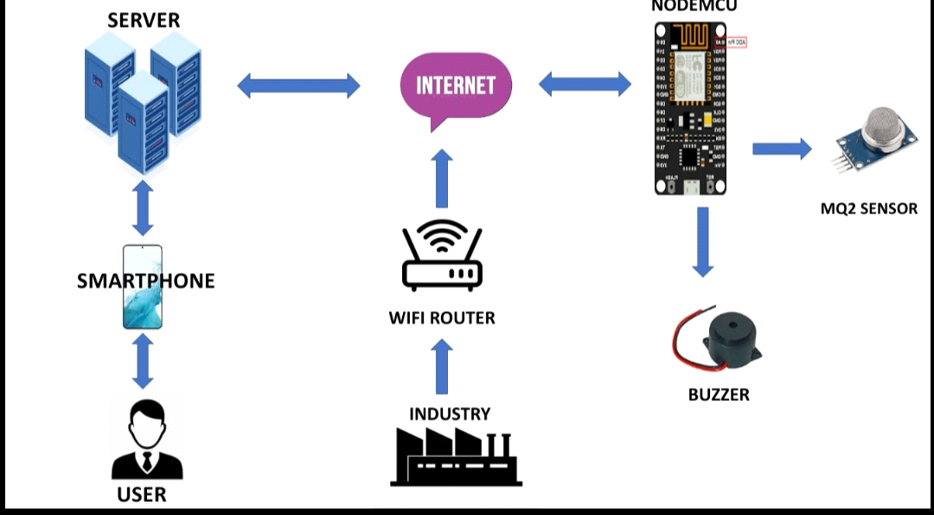

**TECHNICAL ARCHITECTURE**

